**ASSIGNMENT**

|  |  |
| --- | --- |
| he190680 | Tran tri dung |
| HE191408 | Trinh hoang ha |
| HE180486 | NGuyen truong an |
| HE182138 | ngo hoang anh duc |
|  |  |

Teacher: Nguyen thi oanh

DBI202 – DATABASE SYSTEM OF DORM FPT UNIVERSITY

October 1, 2024

# TABLE OF CONTENTS

## INTRODUCE THE PROBLEM …………………………………………………………………………

### Describe the problem …………………………………………………………………………………………..

### Management objectives ……………………………………………………………………………………..

## entity – relationship – er ………………………………………………………………………

### definITION entity – attributE ………………………………………………………………………………

### set up entity – relationship ………………………………………………………………………………..

# INTRODUCE THE PROBLEM

## Describe the problem

Currently, at FPT University in Hanoi, students residing on campus are accommodated in Dormitories A, B, C, D, E, F, G, and H. These dormitories have various staff members, including managers, laundry staff, security guards, cleaners, and maintenance workers. Based on a survey conducted at the dormitories, the group has gathered the following information:

* Students are assigned to rooms, and each student is allowed to stay in only one room.
* Each dormitory has several staff members. Information about each staff member includes: Staff ID, full name, date of birth, gender, phone number, email, dormitory code, and job position code.
* Details of each staff position include: Position code, position title, and monthly salary.
* The dormitory manager keeps a list of the students residing in their dormitory, including information such as: Student ID, full name, email, phone number, date of birth, gender (either Male or Female), and the student's phone number, which starts with a "0" and contains 10 digits.
* Rooms are also divided by gender, so a student’s gender must match the gender of the room they are staying in.
* Each student is recorded in a registration list that includes: Student ID, room code, check-in date, and status.
* The payment history for student room fees each term will be recorded. If a student has not paid the full room fee, it will show "UNPAID," and if the payment is complete, it will show "PAID."
* Each student will also have information about the rooms they have previously stayed in, including: Student ID, term code, and room code.
* Rooms in the dormitories can accommodate a maximum of 4 or 6 students. Each individual room exists in only one dormitory.
* If the number of students in a room is less than the room’s capacity, additional students may be admitted.
* Room information includes: Room code, dormitory code, floor, room number, side, gender, and current number of students. Rooms are divided into two sides, Left (L) and Right (R). The room code format begins with a letter (A-H, depending on the dormitory), followed by the floor number (1-5), the room number (01-14), and ends with either "R" or "L" depending on the side.
* Each term, rooms will collect electricity and water fees. Information on electricity and water usage includes the room code, term code, electricity consumption, and water consumption.
* Each dormitory can have one or more security guards, but each security guard is assigned to only one dormitory.
* Information about each dormitory includes: Dormitory code, dormitory type, and the room’s price.

**Request:**

* The dormitory manager is required to check the number of students checking in and checking out each day.
* The security staff must inspect and report the condition of the facilities.
* Each term, the dormitory manager will review and report any students who have not paid their room fees for that term.
* The dormitory manager will verify student information.
* The dormitory manager will also check the status of rooms to see which ones are available for student registration.
* If the security staff detects any damage during their facility inspections, they will report it to the technical department so that technicians can carry out repairs.

## Management objectives

* Manage the number of students currently staying and the number of students checking in and out.
* Manage the availability of rooms to determine whether there are vacancies for student registration.
* Manage and inspect the condition of the facilities in each dormitory.
* Manage the electricity and water bills for each room in the dormitories.

**Important output**

* The total room fee for students each term.
* The total electricity and water bill for students each term.
* A list of facilities that have been repaired and those that need repairs

# entity – relationship – erD

## difinITION entity – attributE

Base on the problem description and management objectives, we can present several entities and attributes of the entity as follow:

* DOM (**ID**, Name)
* ROOM (**ID**, **DomID**, Floor, Position, Side, Gender, Type, Price, NumberOfStudent)
* STUDENT (**RollNumber**, FirstName, LastName, DateOfBirth, Gender, PhoneNumber, Email, Balance, Semester, RoomID, DomID)
* SEMESTER (**ID**, Name, StartTime, EndTime)
* ELECTRICITY_WATER_USED (**RoomID**, **DomID**, **SemesterID**, SoSElectricityReading, EoSElectricityReading, SoSWaterMeterReading, EoSWaterMeterReading)
* RESIDENT_HISTORY (**StudentID**, **SemesterID**, RoomID, DomID)
* PAYING_HISTORY (**StudentID**, **SemesterID**, TotalAmount, Status)
* BOOKING_HISTORY (**ID**, **StudentID**, RoomID, DomID, BookingDate, Status)
* ROLE (**ID**, Name, Salary)
* STAFF (**ID**, FirstName, LastName, DateOfBirth, Gender, PhoneNumber, Email, DomID, RoleID)

## set up entity – relationship

**Some symbols used in the model**

**Attribute**

|  |  |
| --- | --- |
| * Key / identifier attribute | Attribute |
| * Attribute description / description | **ENTITY** |
| * Entity | **WEAK ENTIRY** |
| * Weak entity | *Relationship* |
| * Relationship |  |
| * Connectivity (force) = 1 |  |
| * Connectivity = N   WE HAVE AN ERD: |  |

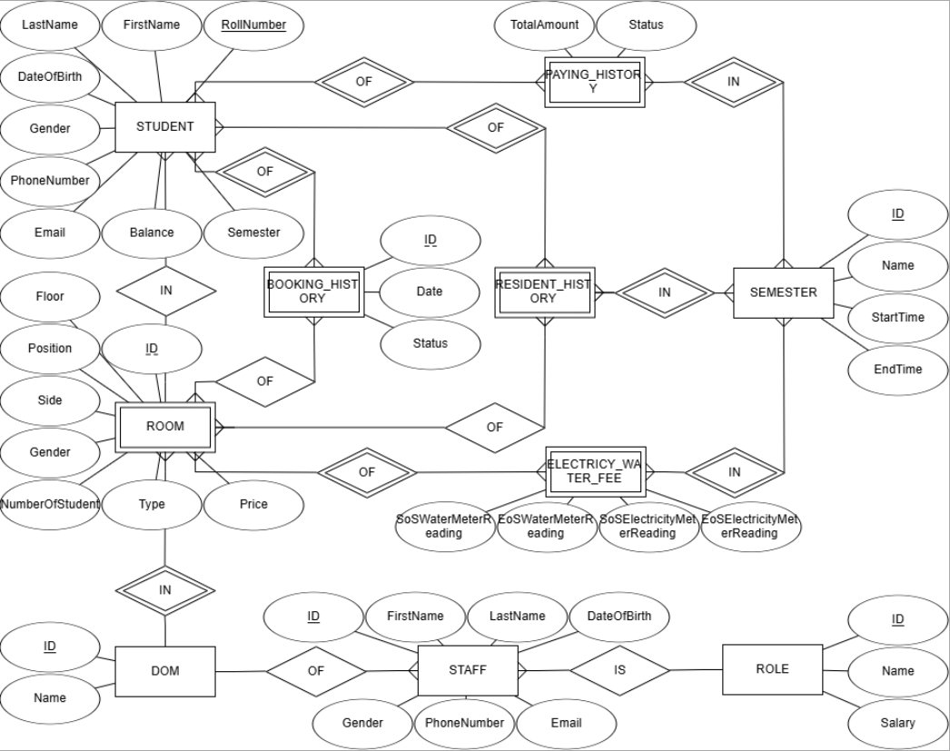

WE HAVE A MODEL:

### 